Experiment 2: Implementation of Cryptanalysis using RSA.
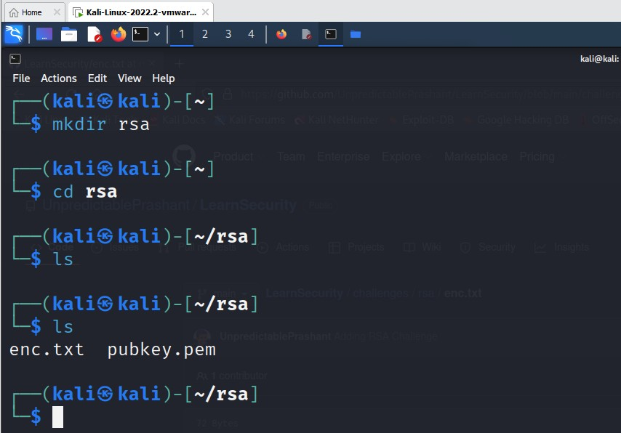

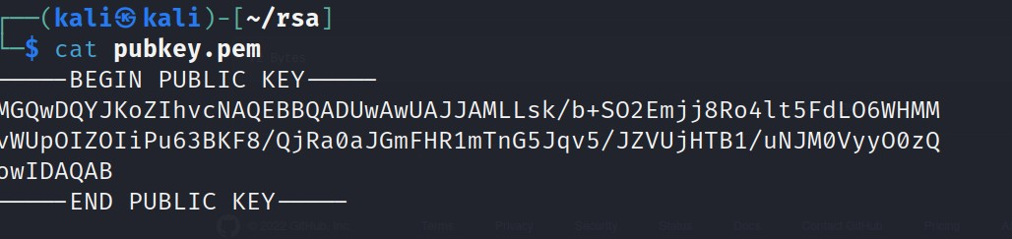
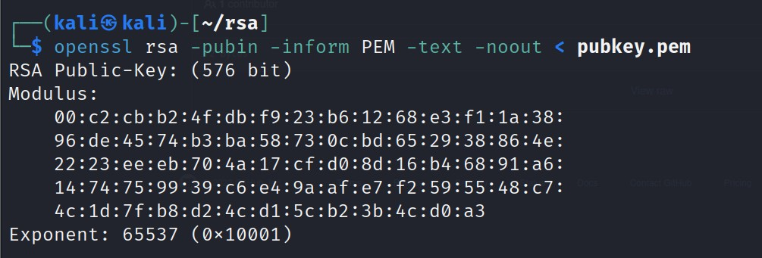
x
Copy the hexadecimal decimal code into a notepad as n value. As it is a hexadecimal we can convert it into decimal for gaining the plaintext.

Hexadecimal to decimal convertor

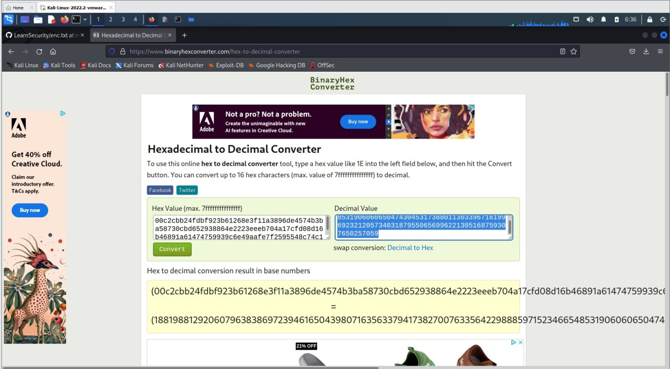

Paste the decimal code in the notepad as n value

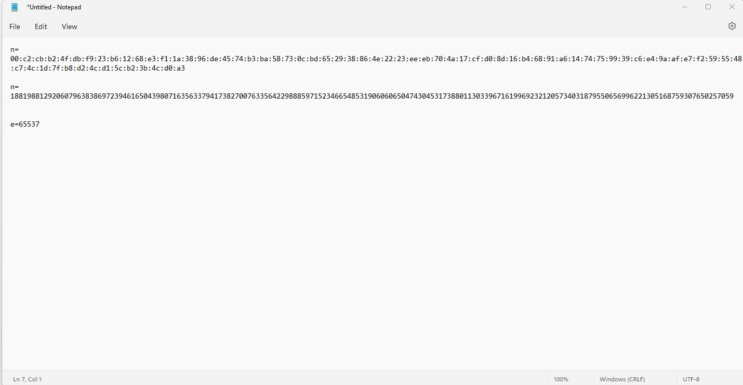

Need to factorize n
So goto website factordb.com click search, paste decimal value of n

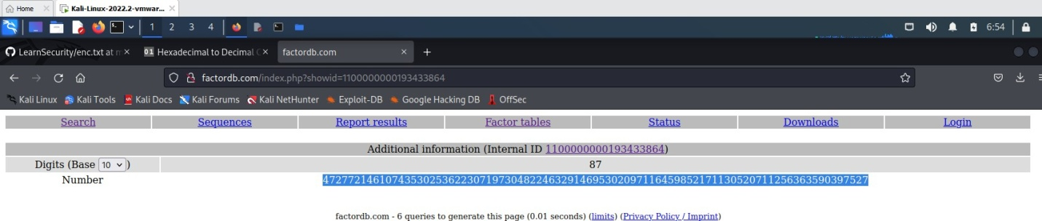

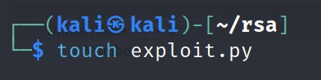
Create a exploit.py
To install pycrypto

pip install pycryptodome
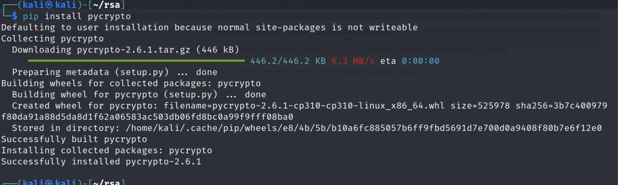
Copy the code in the exploit.py file and paste it from Crypto.PublicKey import RSA
from Crypto.Util.number import inverse import base64
n = 1881988129206079638386972394616504398071635633794173827007633564229888597152
3466548531906060650474304531738801130339671619969232120573403187955065699622
1305168759307650257059
e = 65537
p = 3980750864240649373971255005503864911990643623425267084063851895759463889572
61768583317
q = 4727721461074353025362230719730482246329146953020971164598521711305207112563
63590397527
phi_n = (p - 1)*(q - 1) d = inverse(e, phi_n)
key = RSA.construct((n, e, d, p, q)) fn = "private.pem"
with open(fn, "wb") as f: f.write(key.exportKey())

Execute exploit.py file

-->python exploit.py

To decrypt the text
-->openssl pkeyutl -decrypt -in encryptedFile -out decryptedFileName -inkey privateKey.pem

Result:
Thus the implementation of RSA algorithm was executed sucessfully.

